**Energy Demand Estimation Using Time Series Forecasting**

# Problem statement

Energy demand forecasting is a key topic in power network planning and operation. Based on the estimated demand, resources like generation, transmission and distribution network are scheduled and operated. Also forecasted values determine the price of energy on the electricity market.

Inaccurate energy demand forecasting can cause following issues:

* Increased operational losses
* Improper resource planning
* Unstable power network operation under extreme cases

There is always is drive in the industry to improve forecasting accuracy by either using new techniques or capturing additional information like customer energy consumption profiles etc. Current state-of-the-art methods in energy demand forecasting are driven mostly by statistical techniques like average values using historical data.

There is always scope of further improvement in forecasting accuracy. Machine Learning techniques have shown promise in time series forecasting domain and this is the main motivation of the capstone project – to explore machine learning techniques for energy demand forecasting.

# Industry/ domain

Energy demand forecasting come from power systems and electrical energy management domain. As mentioned above, current state-of-the-art in the industry is using statistical techniques.

The machine learning approaches explored in this capstone project for energy demand forecasting can be easily extended to other domains like sales demand forecasting, daily patient count estimation in a hospital etc.

# Stakeholders

Power utilities, generation companies, energy distribution companies and the end customer are all stakeholders in this problem. Inaccurate demand forecasting affects all parties that are involved in the supply of electrical energy, starting from the energy producers to the end consumers. Also electricity price in energy trading market is hugely influenced by the forecasted energy demand.

# Business question

Accurate demand forecasting enables stakeholders like generation companies and utilities to schedule their resources in an optimal way and minimize operational cost. This also leads to determination of optimal price point for electricity in the market.

# Data question

Recorded energy consumption values are plotted as a time series plot and the approach is use these historical demand values for energy forecasting in near future. The underlying motivation is that historical energy consumption values follow a pattern which a machine learning model can attempt to capture, under the assumption that future values will also be driven by this pattern.

# Process overview

The following diagram shows the overall end-to-end process for defining, designing and delivering the Capstone project.

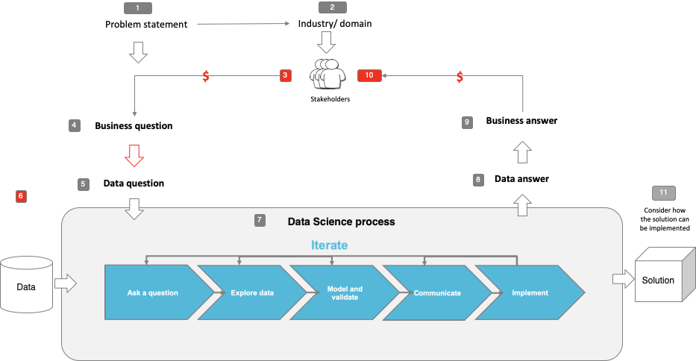

# Data

Energy demand data is taken from a Victorian utility website for last 6 years, captured with a daily frequency. This data is continuously captured and in future additional data can be used in training the algorithm.

# Data science process

## Data analysis

Energy demand data is plotted as a time series plot. It is evident from this plot that there is a periodic component in the values that depend on the month of the year. In addition there are peaks seen in the plot, which are indicative of the fact that there are some external factors that affect this measurement. These external factors could be like ambient temperature during the day etc.

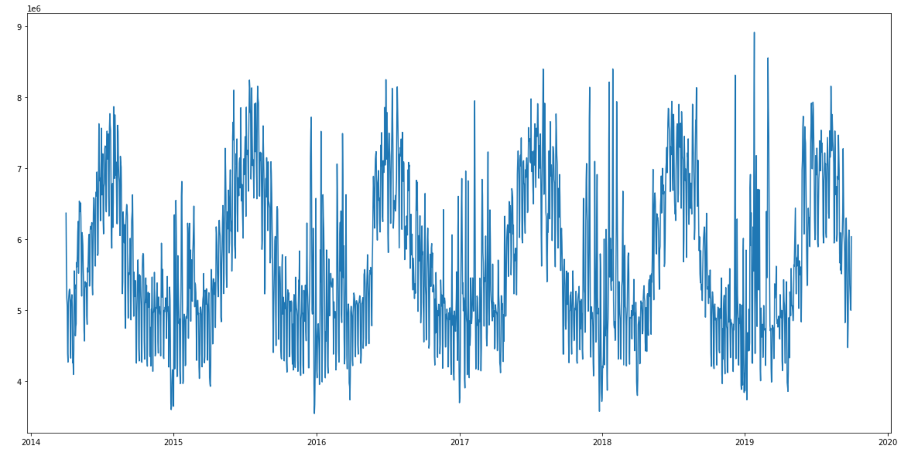

## Modelling

Time series forecasting techniques have been used in this capstone to estimate future energy demand. Two approaches have been considered:

* Prophet from Facebook : is an open source library that fits a mathematical model to data for capturing its content. This model tries to capture two main components
  + Trend – component which shows the behaviour of the time series on an average. It could be increasing or decreasing.
  + Seasonality – periodic component whose value follows a pattern depending on the time of the year.
  + Residual – remaining value of time series that is not explained by above to components.
* NeuralProphet : is an extension to Prophet with an additional of feed forward neural network for auto regression.
  + The idea here is to training a neural network using historical value to a certain number of time steps back in time (called lag) and use the predicted value to augment the mathematical model created by Prophet.

Baseline model has been created for comparison of performance of above two approaches using average values from the historical data.

To demonstrate the effect additional information can have forecasting accuracy, additional feature was added to the dataset that attempted to capture the peaks. Whenever the demand values was more than a certain threshold, this feature was set as 1 to indicate presence of some external factor.

The forecasted values are evaluated using the following metrics:

* Mean Absolute Percentage Error (MAPE)
* Mean Absolute Scaled Error (MASE)
* Mean Absolute Error (MAE)
* Root Mean Squared Error (RMSE)

## Outcomes

Following plots show the forecasting results for a future horizon of 180 days.

Prophet – Horizon 180 days

|  |  |  |  |
| --- | --- | --- | --- |
| **PROPHET** | | | |
| MASE | MAPE | MAE | RMSE |
| 1.069 | 6.914 | 421150.14 | 528859 |

NeuralProphet – Horizon 180 days

|  |  |  |  |
| --- | --- | --- | --- |
| **NEURAL PROPHET** | | | |
| MASE | MAPE | MAE | RMSE |
| 1.056 | 6.86 | 415976.45 | 514259.46 |

|  |  |  |  |
| --- | --- | --- | --- |
| **BASELINE AVERAGE (MODEL)** | | | |
| MASE | MAPE | MAE | RMSE |
| 1.072 | 7.09 | 422085.29 | 527047.56 |

NeuralProphet with external factor – horizon = 180 days

|  |  |  |  |
| --- | --- | --- | --- |
| **MASE** | **MAPE** | **MAE** | **RMSE** |
| 0.88 | 5.734 | 349350.37 | 435786.79 |

# Data answer

It can be seen that both Prophet and NeuralProphet perform better than baseline average model and NeuralProphet does slightly better than Prophet.

# Business answer

As explained in previous sections there is always a quest for improving forecasting accuracy by using new techniques. The results in this capstone projects show that machine learning based models can provide good results.